Guideline Overviews

General Rules

- Always use a portrait overview if possible, because this will save valuable paper space. Only when important fields cannot be fitted in, the landscape overview can be used.
- When possible, try to group data. For example, outstanding items should be grouped by debtor, transactions can be grouped per account etc.
- All report must have unique titles. So if two versions of the same report exist, they must have different titles (e.g. ‘Items (Brief)’ and ‘Items (Extensive)’).
- The file name of the report should match the report title. So the file name of the report ‘Outstanding Items per Debtor’ should be: ‘Outstanding Items per Debtor.rpt’.

Crystal Reports Settings

Define the following settings in Crystal Reports (menu path: File, Options):

Tab: Layout
- Snap To Grid: On
- Grid Size: 1mm
- Show Field Names: On
- Free-Form Placement: On

Tab: Fields, String, Tab: Common
- Can Grow: Off

Layout

- Page margins for portrait documents are:
Landscape: Top: 1,5 cm
Bottom: 1,2 cm
Left: 1,5 cm
Right: 1,5 cm

Portrait: Top: 1,5 cm
Bottom: 1,2 cm
Left: 1,5 cm
Right: 1 cm

- The margin between the last row on the page and the footer should be at least 6 mm.
- All texts are in Arial 8-point normal, unless indicated otherwise.
- All lines used are 0.25 points thick (“hairline”), color black, unless indicated otherwise.
- Distance between all ‘blocks’: 5 mm.

Data Fields

- It is not allowed to place data fields on multiple lines! If all columns do not fit in a landscape overview certain columns should be left out. The product groups decide which fields to exclude.
- It is not allowed to let data fields grow over multiple lines (option “Can Grow” must be disabled). For example: when a description is too long for the data field, it cannot be continued on a second line. Only by permission of the product group, an exception to this rule can be made.
- The minimum distance between data fields is 4 mm. When data fields are separated by a line (in data block), the minimum distance between data field and line is 1 mm.
- The field length is calculated as follows:

Description (fixed):
Field Length (mm) = Max. number of characters (Determine in P1) * 2.0

String/Amount/Quantity (variable):
Field Length (mm) = Max. number of characters (Determine in database) * 2.0
Grouping on one level
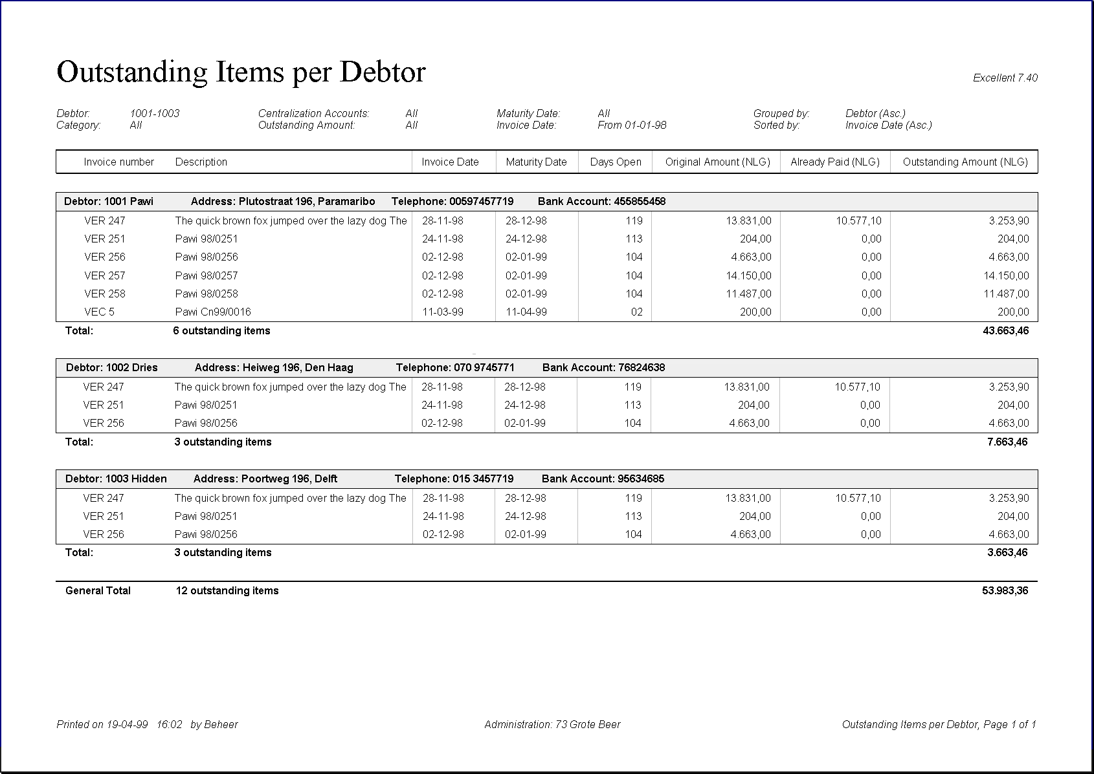
Report title (only on first page).
Times New Roman, 24-points, normal. Left aligned.
Header block (repeated on every page).
Block height: 6 mm.
Multiple rows are not allowed! The alignment of header fields matches the alignement of the data fields. The width of the horizontal lines is 1 point, color black.
Text “Excellent” + Version NR.
(only on the first page).
Arial, 8 points italic, right aligned.
Text “Printed on “ + date + time + ”by” + user name.
(repeated on every page).
Arial, 8-points, italic.
Text “Administration “ +
Admin. code + Admin. Name.
(repeated on every page)
Arial, 8-points, italic.

Group block.
Arial, 8-points, bold, left aligned, indent: 2mm.
Block height: 5 mm. Color: R240, G240, B240.
On the far left a description of the group (in this case “Debtor” is shown, followed by the code and description of the group member.

Data block.
Line height: 4 mm. Arial, 8-points, normal.
The first culumn is indented 6 mm from left page margin.
All texts are left aligned. All amounts and numbers are right aligned.
Spread columns evenly over the total table width.
Data should be broken off with a hairline (color: black) when continued on the next page.
Properties block (only on first page).
Arial, 8-points, italic.
Use as few lines as possible. All selection criteria must be shown as well as the standard currency. If a filter can be applied in the selection screen, the filter reference and description must be included in the properties block as well.

Report name + “, ” + “Page” +
Page number + “of” + total pages.
(repeated on every page)
Arial, 8-points, italic. Right aligned.

Subtotal.
Arial, 8-points, bold.
The product groups determine which subtotals must be displayed. The total number of data rows (in this case: outstanding items) can be shown as well (only if this is useful information). These filelds should be left aligned.

General Total.
Arial, 8-points, bold. Line width: 1 point, color: black.

“Sorted by” (always) and “Grouped by” (only if grouping is applied) should be placed on the right. Put ‘Asc.’ (ascending) or ‘Desc.’ (descending) after ‘Sorted by’.

Layout Details

Margin: 5 mm
Margin: 5 mm
Margin: 5 mm
Margin: 5 mm
In the group headers (label,) code and description (in this case ‘debtor’, ‘1001’ and ‘Pawi’) must be put in 1 field. Use margins of 3 spaces.
All other margins between group header fields are 4 mm.
Properties block: Margins between descriptions and values are 4mm. Margins between columns within the properties block are 12 mm.
The margin between the first field in the group header (containing code & description) and the second field is 12 mm.
When data fields are separated by a line, the minimum distance between data field and line is 1 mm.
The minimum distance between the data fields code and description is 4 mm.
Margin: 5 mm
Margin: 5 mm
Columns with subtotals should be placed on the far right.

Two Lines in Group Block

- All properties of a group member should be fitted into one line. However, when all important property fields cannot be fitted in, you are allowed to use 2 lines (total height: 10 mm)

- When using two lines, make sure that the first field on the second row is aligned with the second field of the first row (in this case “Address”). The description and code of the group member (debtor in this case) should stand alone on the left.

- Multiple lines are not allowed in the header block (Exception to this rule on page 5).

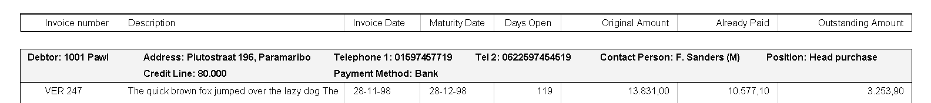

Groups on multiple levels
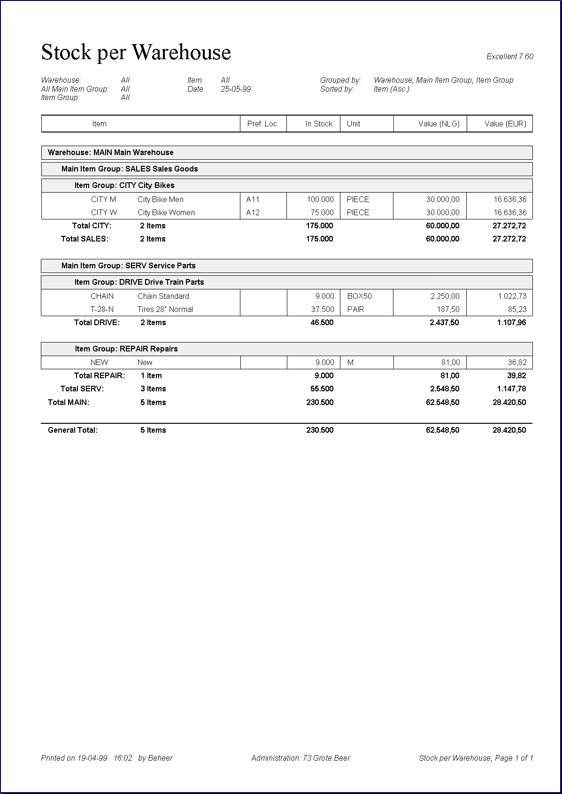
Grouping on multiple levels can be applied. However do not group data on multiple levels if this does not improve the clearness of the overview.
Multiple Group Blocks.
Arial, 8-points, bold.
The group on the highest level starts on the far left (indent: 2 mm). Every subgroup is shown at the top of a new report. Each subgroup is 4 mm from the subgroup above. The space between group blocks is 1 mm. (tip: place a white box of height 1mm underneath the gray group block in Crystal Reports)

The number of gray group blocks that is shown in the rest of the report depends on the level of the new (sub)group. In this case:
When a new Item group (level 3) begins, one gray group block is shown. When a new Main Item Group (level 2) begins, 2 gray blocks are shown. When a new Warehouse (level 1) starts, three blocks are shown.

Multiple Subtotals.
Arial, 8-points, bold.
The Product Groups decide which subtotals should be shown as this depends on the type of overview. Subtotals always include the group code when grouping on multiple levels is applied. They are aligned with the group header the subtotal belongs to. (In this case “Total CITY” is aligned with “Item Group”, “Total SALES” is aligned with “Main Item Group” and “Total Warehouse MAIN” is aligned with group header “Warehouse”)

If grouping on multiple levels is applied, all groups must be displayed (from high level to low level) in the properties block.

There is a maximum of 4 levels when grouping data:
Main group, Subgroup 1, subgroup 2 and group item (in the example below:
1. Warehouse, 2. Main Item Group, 3. Item Group and 4. Item). This means that a maximum of three gray group blocks can be used.

No Grouping

- With no grouping only the header block is shown (no gray group blocks). The color of the header block is gray, color: R240, G240, B240 (only in this overview type).

- Descriptions in the header block should be abbreviated so that all description can be fitted into one line.

- If the abbreviated descriptions in the header cannot be fitted in a block with height 6 mm, you are allowed to use two lines (exception!). In that case the height of the header block becomes 8 mm and descriptions in the header block are top aligned.
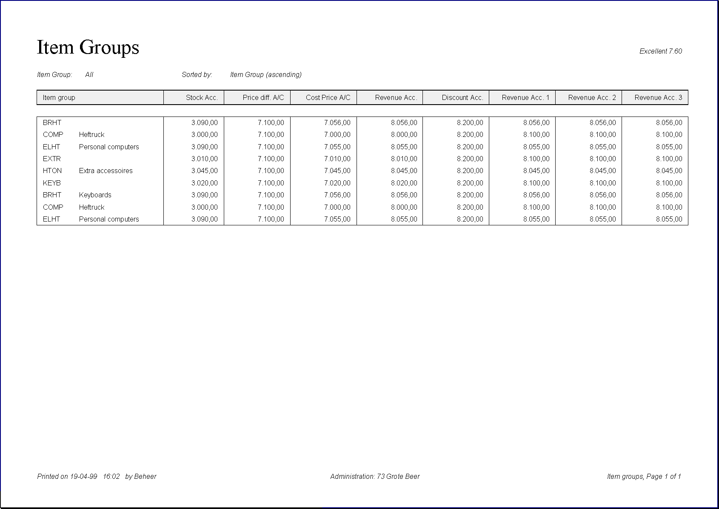

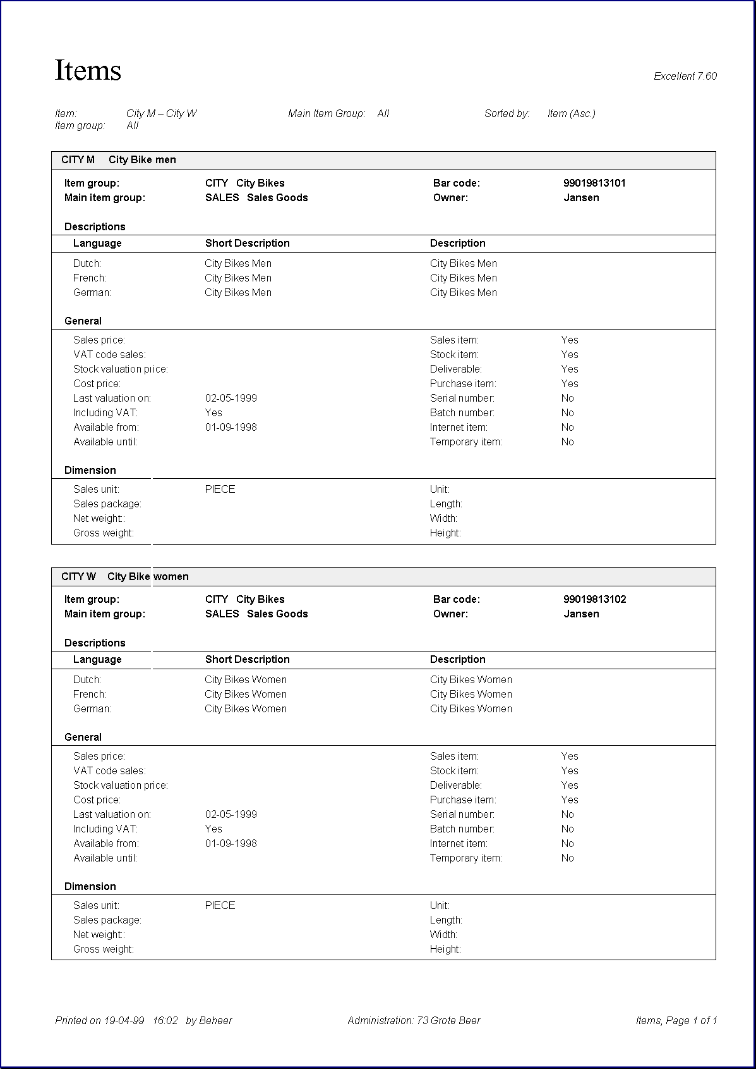
Master Data Overviews
Group block.
On the far left a description of the group (in this case “Bank Account”) is shown, followed by the code and description of the group member.

Data 1 (optional).
Arial, 8 points, bold. Row height: 4 mm.
This field contains the most important information about the group member. Use a margin of 2 mm between the group header and this data field.

Section header.
Arial 8 points, bold. Indent: 2mm.
In case a of information must be displayed, a number of sections can be introduced. Under each section header a harline is displayed (color: black).

Internal table.
In case some master data properties have multiple values, a table inside the master data over view can be used. Descriptions of field are in Arial, 8 points, bold. Two lines (hairline) are used to separate description fields from the data fields.

Section Data.
Indent: 2mm. Row height: 4 mm.
When no sections are applied, this additional information is shown without a section header, indent: 0 mm. In that case, use a distance of 5 mm between these fields and the “Data 1” block.
Vertical margin between last field and line: 1 mm

- Use this layout only when all columns cannot be fitted in the normal (landscape) overview layouts as described on the previous pages (too much information).

- Master data overviews are always grouped.

- Always use the portrait orientation for this view.

- Always use 4 columns. The third column starts at the horizontal center of the page + indent 4 mm.

